Paper 001-2025
An Explanatory Analysis of Power-Factor Efficiency and Peak Loads in Steel-Plant Operations
Andre Ong Jia Kang; Ng Jin Yao; Nor Hendra Bin Abdul Rahman, Singapore Management University
ABSTRACT
Industrial energy optimization is critical for cost savings and power grid stability, particularly in energy-intensive sectors like steel manufacturing. While prior research on the target steel plant's dataset focused on predictive forecasting, this study adopts an explanatory modelling approach to identify the underlying drivers of two critical operational problems: high power-load (peak) events and low power-factor (inefficiency) events. Using a year of 15-minute interval IoT data from a South Korean steel plant, this analysis develops two binary logistic regression models to explain "why" and "when" these events occur.
The models demonstrated excellent discriminatory power (AUC: 0.978 for high load, 0.961 for efficiency). Key findings reveal that peak load events are strongly driven by increases in lagging reactive power (Lagging_CRP_kVarh) and are most associated with the Medium_Load operational state and with Saturdays. Power factor inefficiency (Lagging CPF < 0.90) was found to be most pronounced during Light_Load periods, while the plant operates most efficiently during Medium_Load states and on weekends (Saturday, Sunday). Leading reactive power (Leading_CRP_kVarh) was confirmed as the strongest predictor of efficiency.
By shifting the focus from prediction to explanation, this analysis provides plant operators with actionable data-driven insights. It pinpoints specific operational states (e.g., Medium_Load for peaks, Light_Load for inefficiency) and time-based windows for targeted interventions, such as production process investigations, rather than generic power savings.

INTRODUCTION
Industrial energy use is a major component of global energy consumption, often surpassing other sectors in magnitude (EIA, 2025). In recent years, smart city initiatives and sustainability goals have driven interest in optimizing industrial energy consumption for both cost savings and environmental impact. Efficient energy use in industry not only reduces operational costs but also curbs carbon emissions and alleviates stress on the electrical grid. A particularly important industrial case is the steel manufacturing sector, which operates energy-intensive processes around the clock. In such settings, identifying when and why energy use spikes (peak demand) or when power is used inefficiently (low power factor) is crucial. Addressing these issues can lead to strategies like load shifting, equipment scheduling, and power factor correction to improve overall efficiency.
This report examines a year’s worth of high-resolution (15-minute interval) operational data from a small-scale steel plant in South Korea (Daewoo Steel in Gwangyang). The dataset, collected via IoT-based monitoring, includes electrical load measurements and power quality metrics such as reactive power and power factor. A prior study by (Satishkumar, Shin, & Cho, 2021) applied predictive modelling (using algorithms like linear regression, CART, SVM, KNN, and Cubist) to this same dataset in order to forecast energy consumption. They found that a Cubist regression model achieved the best prediction accuracy, highlighting the potential of data-driven approaches for energy management. In contrast, our analysis takes an explanatory modeling approach which focuses on understanding the drivers of certain outcomes (rather than just predicting values) in order to inform operational decisions. Specifically, we investigate two critical aspects of the plant’s energy usage: (1) periods of high power load demand, and (2) periods of low power factor (indicating inefficient power usage). By using binary logistic regression models for these two outcomes, we aim to uncover which factors (time-of-day, load types, reactive power levels, etc.) significantly influence the likelihood of peak demand or poor power factor conditions. This explanatory perspective complements the previous predictive study by providing deeper insight into why and when problematic energy events occur, thereby enabling more informed interventions.

PROBLEM STATEMENT
The steel plant experiences variability in its power consumption and power quality over time. Two key problems have been identified from an operations standpoint:
- Peak Demand Events: Occasions when the plant’s electrical load is extremely high (relative to normal operation). These peak demand periods can lead to disproportionately high costs due to demand charges and can strain both the facility’s equipment and the local grid. Uncontrolled peaks are inefficient and may signal opportunities to redistribute or reduce loads.
- Low Power Factor Episodes: Periods when the plant’s lagging Current Power Factor (CPF) drops below acceptable efficiency thresholds (we focus on lagging power factor since inductive loads in heavy industry often cause current to lag voltage). A low power factor implies that a significant portion of the power drawn is non-productive (reactive), causing increased current draw for the same real work. This inefficiency incurs financial penalties from utilities and results in higher losses in the electrical distribution system (YT Electric, 2024)
Given these problems, the plant management needs a data-analytic solution to identify when these undesirable conditions are likely to occur and understand what factors drive them. The overarching problem can be formulated as: How can we characterize and predict the occurrences of peak load and low power factor in the steel plant, and what operational factors influence these events? By answering this, the plant can take proactive measures such as rescheduling certain operations or adding power factor correction capacitors, to mitigate peaks and improve efficiency.

OBJECTIVES
The objectives of this analysis are as follows:
I. Identify High Load Periods: Define a clear criterion for what constitutes a high load event using the plant’s energy data usage and create a binary classification (High vs. Low load). We adopt the 95thpercentile of the distribution of 15-min interval energy usage (kWh) as the threshold for “High Load.” This means any interval where usage exceeds the 95th percentile is flagged as a peak demand period. The choice of the 95% threshold is grounded in industry practice and literature. It captures the extreme upper tail of consumption without being as rare as only the absolute maximum, aligning with definitions of “peak” used in prior research (Gajowniczek & Zabkowski, 2017). One objective is to build a logistic regression model that classifies whether a given time interval is a High Load event (above 95th percentile) or not, based on predictors like time-of-day, day type, and power quality measures.
II. Identify Low Power Factor Periods: Similarly, define a binary outcome for power factor efficiency. We use a threshold of 0.90 (90%) on the lagging power factor (Lagging CPF) to distinguish “Efficient” vs. “Inefficient” intervals. If the lagging power factor is below 0.90, we label the interval as Inefficient (low PF); if it is ≥0.90, as Efficient (acceptable PF). This 90% criterion reflects common utility standards which many utilities impose penalties or surcharges for customers whose power factor falls below 0.9 (Schneider Electric, n.d.). Thus, maintaining PF at 0.9 or above is typically required to avoid extra costs. A second logistic regression model will be developed to explain the likelihood of an interval being Inefficient (PF < 90%), as a function of operational variables such as reactive power levels, load type, time, etc.
III. Explain Key Drivers: For both models, the goal is not just classification accuracy but interpretability. We will examine the regression coefficients to understand which factors significantly increase the odds of a High Load event or a Low PF event. By quantifying these relationships, we aim to provide actionable insights. For example, identifying if certain load types such as heavy machinery operation or certain time windows (e.g., specific hours of the day or shifts) are strongly associated with peaks or low PF. This ties back to practical decisions: if peaks are driven by specific processes or times, those can be rescheduled or smoothed out; if low PF is driven by certain equipment, capacitive compensation can be targeted there.
IV. Complement Predictive Modelling with Explanatory Insight: Since a prior study has already addressed pure prediction of energy usage, our objective is to add a new perspective by focusing on explanation. We will compare our findings with literature and the original research to see how an explanatory approach can yield insights that might be obscured in a prediction-focused analysis. Ultimately, the objective is to demonstrate that understanding the why behind energy patterns in this steel plant can lead to better energy management strategies in an industrial setting.

LITERATURE REVIEW
I. Industrial Energy Consumption and Peak Demand Management
Industrial facilities are known to be significant energy consumers. According to the U.S. Energy Information Administration, the industrial sector uses more delivered energy than any other end-use sector, roughly 54% of the world’s total delivered energy as of mid-2010s (EIA, 2025). Within industrial energy management, one critical challenge is managing peak demand. Peak demand refers to short periods of exceptionally high power draw, which can disproportionately affect energy costs. Utilities often levy demand charges based on the highest peak usage in a billing period, meaning a few spikes can drive up costs even if average usage is moderate. Prior studies have emphasized the value of forecasting and mitigating peaks to reduce operational costs and improve grid stability (Gajowniczek & Zabkowski, 2017). For instance, Gajowniczek and Ząbkowski (2017) proposed a two-stage approach where they first classified peak load events and then used that information to improve load forecasting. In their work, a “peak” was defined rigorously using statistical quantiles: an extraordinary load was any value at or above the 90th, 95th, or 99th percentile of the load distribution for a given timeframe. This percentile-based definition of high load is common in research and practice as it captures the extreme tail of consumption while providing a flexible cutoff. Some utilities or studies may choose the 90th percentile to identify unusually high usage, whereas others might use the 95th or 99th for a more stringent definition. The 95th percentile threshold we employ in our analysis aligns with these practices, effectively flagging the top 5% of consumption instances as “High Load”. By doing so, we focus on the most significant surges in demand that would likely interest facility managers and utility providers. Literature suggests that addressing these peaks through techniques like peak shaving, load shifting, or demand response can lead to substantial cost savings and improved energy efficiency. Moreover, identifying patterns in when peaks occur (for example, specific hours of the day or days of the week) can inform scheduling decisions. In building management and industrial contexts, researchers have observed strong temporal patterns in energy use; for the steel plant data specifically, Sathishkumar et al. noted that energy consumption is lower on weekends and rises starting 8 AM on weekdays, remaining steady until evening. Such patterns indicate that operational schedules heavily influence demand, reinforcing the need to analyze time-of-day and day-of-week effects in peak occurrence.
II. Power Factor and Energy Efficiency in Industry
$PF= \frac{P}{\left|S\right|}=cos φ$, $\left|S\right|= \sqrt{P^{2}+ Q^{2}}$
Power Factor (PF) is a measure of how effectively electrical power is being used. In AC circuits, PF is defined as the ratio of real power (the work-producing power, in kW) to apparent power which is the total power drawn from the source, in kVA (FLUKE, n.d.). A power factor of 1, or 100% is ideal, meaning all drawn power is used for productive work. In contrast, a lower power factor indicates that a portion of the electrical power is not doing useful work, but instead is oscillating as reactive power in the system such as charging and discharging magnetic fields in motors. In an industrial setting with heavy inductive loads (motors, transformers, arc furnaces, etc.), it is common to have a lagging power factor, where current lags voltage. A lagging PF below 0.9 is widely viewed as inefficient and problematic (YT Electric, 2024). The consequences of low PF are well documented: the facility draws higher current for the same amount of real power, which increases I²R losses in cables and transformers and can necessitate oversized equipment capacity (All About Circuits, n.d.). Because of these inefficiencies, utilities typically impose penalties or surcharges on commercial/industrial customers whose power factor falls beneath a threshold (often 0.90 or 0.95). For example, Schneider Electric notes that many utilities require PF above 0.90 to avoid penalties, effectively incentivizing customers to correct their power factor (Schneider Electric, n.d.). Another industry source similarly highlights that a poor power factor (below 0.9) will incur higher demand charges and reduce the available capacity of the electrical infrastructure.
Improving power factor typically involves installing capacitors or synchronous condensers to provide reactive power locally and thus reduce the reactive power drawn from the grid. This is known as power factor correction (PFC). The steel plant dataset includes “Lagging Current Power Factor (LagPF)” as a percentage measure, which reflects the PF when the current is lagging (inductive load case). By analyzing when LagPF drops below 90%, we can infer the conditions under which the plant’s electrical system is operating inefficiently. Academic literature on power quality and efficiency often points to certain causes of low PF, such as large motors starting, lightly loaded transformers, or other inductive processes that are not counterbalanced by capacitance (Keysight, n.d.). Additionally, harmonic distortions from non-linear loads can also degrade the power factor, though the dataset at hand primarily captures the fundamental PF rather than detailed harmonics. In our literature review, we did not find a specific prior study focusing on logistic regression for power factor classification in this context, which suggests our approach is somewhat novel. However, the general principle is supported by power systems research: monitoring and classifying low-PF incidents is an important part of energy management since it directly ties to cost and efficiency.
To add scientific rigor to our discussion, it’s useful to recall how power factor is calculated from basic electrical principles. If $P$ is real power in kW and $Q$ is reactive power in kVAR, the apparent power $S$in kVA is $|S|= \sqrt{P^{2}+ Q^{2}}$. The power factor is $PF= \frac{P}{\left|S\right|}=cos φ$. A lagging PF means $Q$ is positive (net inductive load), whereas a leading PF (less common in industry) would mean $Q$ is negative (net capacitive injection). In our dataset, “Lagging CPF” values are given, so presumably a value of 90% means $\frac{P}{\left|S\right|}=0.9$, and the remaining 10% of apparent power is due to reactive requirements. Understanding this formula helps interpret the logistic model: predictors that correlate with low PF might be those that indicate high $Q$ (reactive power) relative to $P$or periods of light real load where fixed reactive draw causes low PF. We will examine variables like Lagging Reactive Power (kVarh) since a high reactive power (LagRP) for a given real power could push PF down. Indeed Sathishkumar et al. found that usage (kWh) had a positive correlation with Lagging Reactive Power, and an even higher correlation with CO₂ emissions, implying the plant’s peaks come with high reactive demand and emissions.
III. Summary of Literature Review
There is a body of literature on energy efficiency interventions in industry. For example, case studies on power factor correction show significant savings. One source documents that correcting PF from 0.75 to above 0.95 in a facility could reduce overall electricity bills by 10-15% due to lower demand charges (Elpro Electric, 2024) (Singh, 2025). Similarly, implementing peak load management (such as using energy storage or load scheduling to cap the peak demand) is often cited as a best practice in plant operations (Optec, 2025). These practical findings support why our chosen classification targets (PF inefficiency and peak demand) are impactful: they directly tie to the plant’s cost and efficiency outcomes.
In summary, the literature suggests that using a percentile-based threshold for peak classification is a validated approach, and maintaining a high power factor (≥0.9) is both an industry norm and a financial imperative. Our study builds on these concepts by employing them in an explanatory modelling framework, thus providing a novel angle on an already well-studied dataset. By referencing established knowledge (e.g., the physics of power factor, and prior research on peak detection) and combining it with our data-driven analysis, we aim to produce a report that is both scientifically grounded and practically useful for industry professionals and academics alike.
DATA METHODS
Data and Pre-Processing
The analysis uses a publicly available steel industry energy dataset from a small plant in Gwangyang, South Korea (UCI Machine Learning Repository, 2018), which contains 35,040 observations recorded at 15-minute intervals over a full year. Each record reports real energy consumption (kWh), lagging and leading reactive energy (kVarh), lagging and leading power factor, CO₂ emissions, and several time-related attributes (number of seconds since midnight, weekday/weekend indicator, and day of week), together with a three-level operational load type. The original publication accompanying the dataset evaluated several predictive models (e.g. SVM, random forest, Cubist) to forecast energy consumption; in this study we use the same source data but reorient the analysis toward explaining operating conditions associated with power-factor inefficiency and high-load intervals rather than benchmarking alternative forecasters.
Before analysis in SAS Viya, we carried out basic structure checks. The 15-minute series spans the full year without calendar gaps, and the row count (35,040 = 365 × 96) is consistent with a complete year of 15-minute data. Column headers in the original CSV were shortened prior to import because SAS Viya imposes a limit on variable-name length in certain tasks; this step was purely cosmetic and did not alter the underlying values.
The timestamp field (originally a single “date/time” column) was decomposed into separate day, month, and time variables to facilitate time-of-day and calendar effects in the logistic models. We also verified the 15-minute granularity by reconstructing the expected daily time grid and checking for missing intervals; no systematic 15-minute gaps were detected in the cleaned file.
In addition to the variables in the source data, we enriched the calendar information. We extracted the official South Korean public holidays for 2018 and joined them to the 15-minute records to create a new binary indicator Is_Holiday (Yes/No). Using this holiday flag together with the existing weekday/weekend indicator (WeekStatus), we then derived a second indicator Is_Workday (Yes/No), defined as “Yes” for non-holiday weekdays and “No” for holidays and weekends. These additions allow us to separate pure calendar effects from public-holiday effects in subsequent models.
To support the explanatory models, we also created two derived operational indicators. First, we defined Is_Inefficient to flag intervals whose lagging power factor was ≤ 90%, reflecting a commonly used threshold for acceptable power-factor performance. Second, we defined is_high_load to flag high-demand intervals by binning the real-power variable (Usage_kWh) at the upper range of the observed distribution (around 100 kWh, corresponding to the tail of the series). These engineered indicators allow us to turn the multivariate time series into classification problems such as “efficient vs not,” “high-load vs not,” and “workday vs non-workday” which can be modelled with binary logistic regression and directly linked back to operational, temporal, and electrical conditions.
The data dictionary for our final dataset can be found in Appendix, Table 2
Numeric Variables
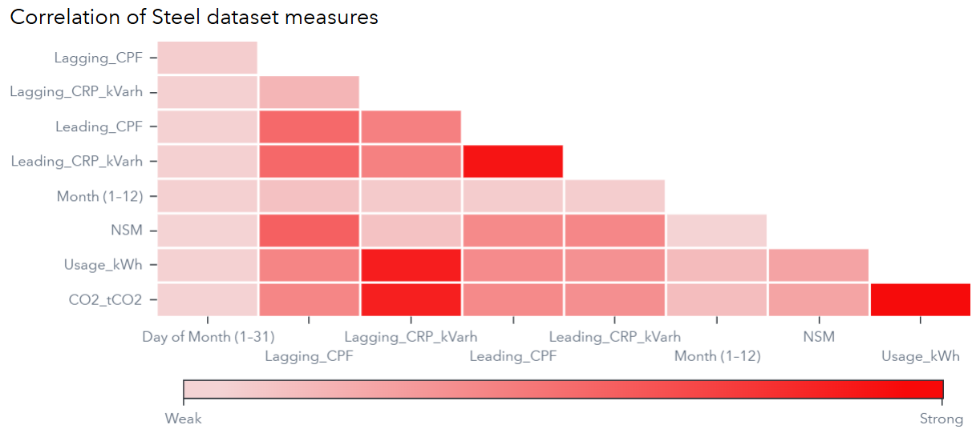
Figure 1. Correlation Analysis of Variables
Correlation analysis was performed to identify pairwise numeric variables that were highly correlated. Highly correlated variables will be
Lagging_CRP_kVarh is highly correlated (>0.85) with CO2_tCO2 and Usage_kWh variables. Thus, based on current focus using Usage_kWh, we opted to exclude CO2_tCO2 and Lagging_CRP_kVarh when performing binary logistic regression.
Leading_CPF and Leading_CRP_kVarh are inversely correlated (-0.85 >). Thus, we will exclude Leading_CPF from our binary logistic regression as Leading_CPF will be used as a variable.

Categorical Variables
Categorical Variables in our cleaned dataset are Is_efficient, Load_Type, WeekStatus, Day_of_week, Is_Holiday, Is_Workday and is_high_load. Mosaic plots were initially done to visualize and explore associations. The area of the tiles represent frequency and proportion of the x-axis variable and colour reflects the variable in the y-axis.
Efficiency Patterns by Operations:
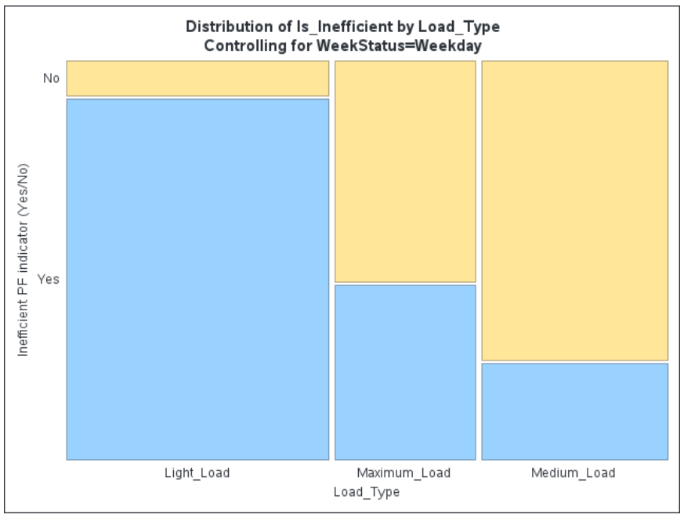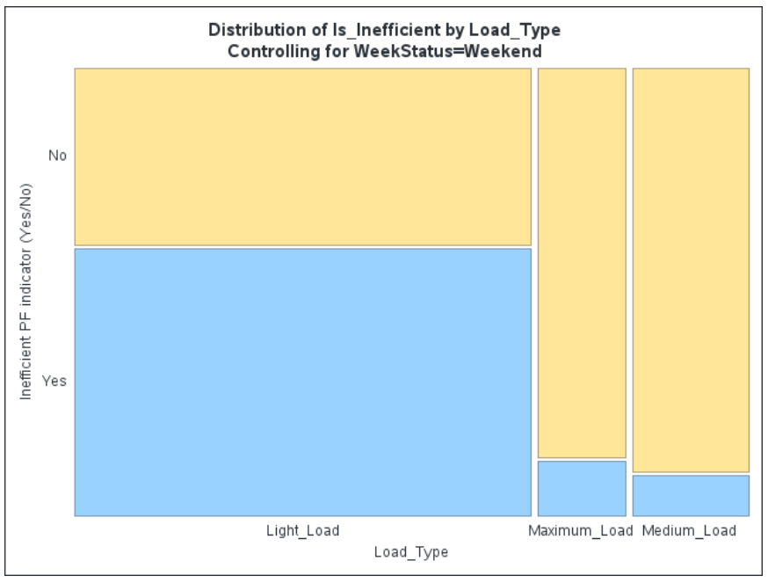
Figure 2. Mosaic Plots of Efficiency Pattern Variables
Through visual inspection, we noticed a difference for efficiency of operations using Load_Type, Is_efficient and WeekStatus as variables. Based on the mosaic plots, we can see equal load_type patterns during the weekdays where inefficiency is high. However, weekends have a higher Light_Load but efficiency improves.
High Load Patterns:
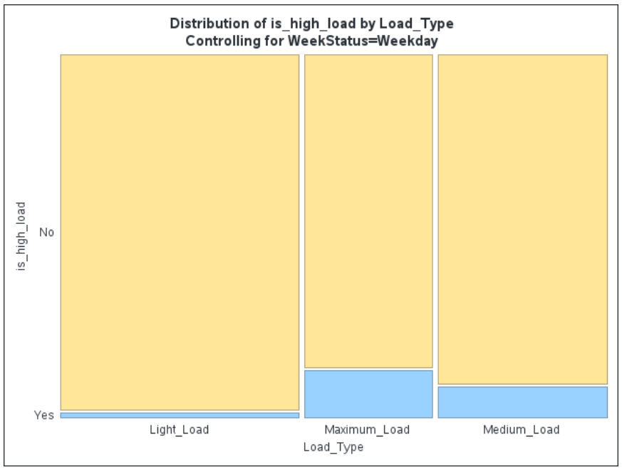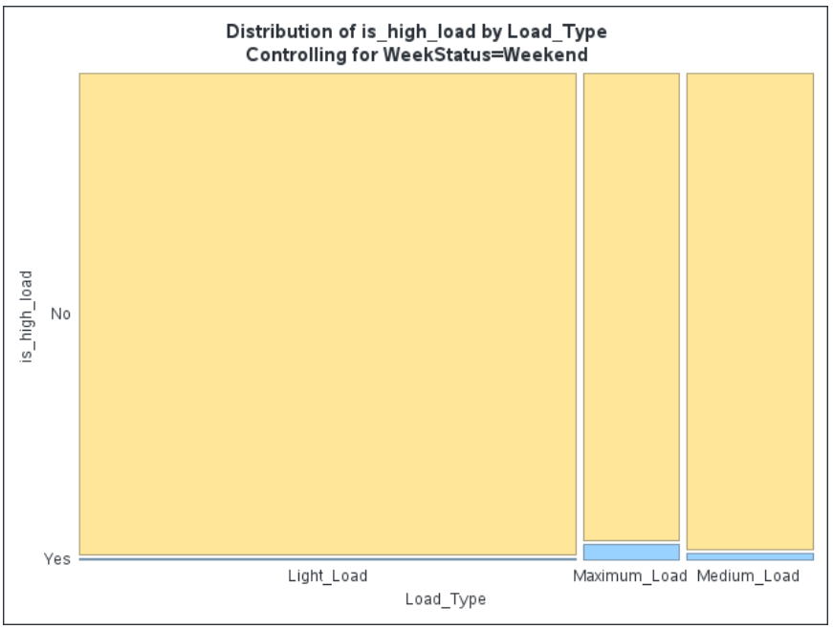
Figure 3. Mosaic Plots of High Load Pattern Variables
Another difference is when we introduced is_high_load against, Load_Type and WeekStatus. There is a pattern difference for Weekday vs Weekend and also the share of high-load by load class.
Based on this, we analyzed the numeric variables of is_inefficient and is_high_load which are Usage_kWH and Lagging_CPF in the next section.

.

Bivariate Analysis
We compared the variables we are focusing on by visualising using histograms.
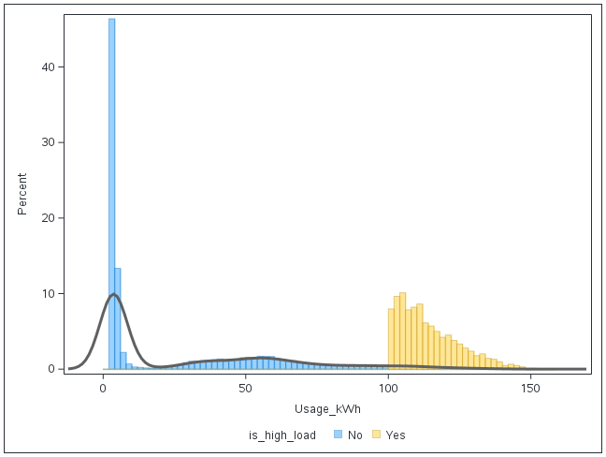
Figure 4. Usage_kWh Histogram Plot by is_high_load
For the is_high_load variable, we can observe complete separation on the Usage_kWh histogram plot. This indicates that the is_high_load variable is suitable for use in a binary logistic regression for the explanatory model.
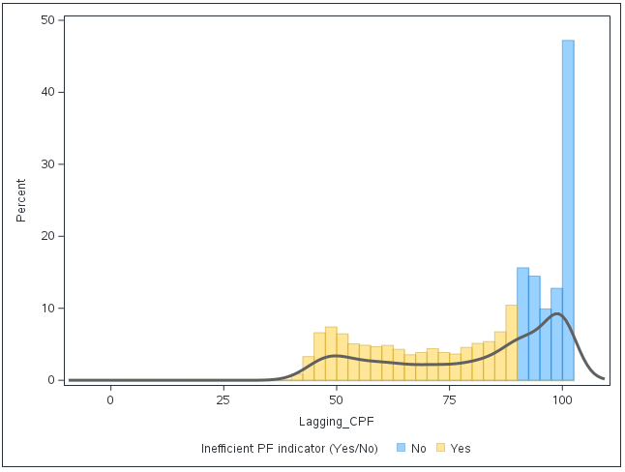
Figure 5. Is_Inefficient Histogram Plot
When Is_Inefficient was plotted as the group of focus, a complete separation was seen for Lagging_CPF variable. This separation indicates the variable is suitable for binary logistic regression.

High Power Load Explanatory Modelling
I. Methods
A binary logistic regression model was fitted to identify conditions associated with the occurrence of a high power load event at 15-minute resolution. The dependent variable was is_high_load, coded 1 for high-load intervals and 0 otherwise. Because several calendar variables in the dataset are structurally related, we treated them carefully during model building. WeekStatus and Day_of_week have a deterministic mapping (Monday–Friday ⇒ Weekday; Saturday/Sunday ⇒ Weekend), and Is_Workday is itself derived from WeekStatus and holiday status; for that reason, only one of these related variables was considered at a time, and Is_Workday was excluded from the final model.
Model development was carried out in SAS Viya using the Binary Logistic Regression task with a logit link and stepwise selection (entry and removal α=0.05). We also ran the same candidate set using forward and backward selection and obtained the same final set of predictors, which indicates that the selected specification is stable for this dataset. Candidate predictors included two categorical variables (Load_Type and Day_of_week) and several continuous/time variables (Lagging_CRP_kVarh, Leading_CRP_kVarh, month, day, NSM). All 35,040 intervals from CASUSER.STEEL_DATA_3 were used, and the SAS output confirms that the modelled event was is_high_load = '1' (1,682 events; 33,358 non-events).
II. Results
Model Building and Overall Fit
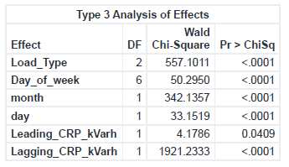
Figure 6. Model Building and Overall Fit - High Power Load Explanatory Model
The stepwise procedure entered effects in the following order: (1) Lagging_CRP_kVarh, (2) Load_Type, (3) month, (4) Day_of_week, (5) day, and (6) Leading_CRP_kVarh. At every step, the newly entered variable was retained, and none were removed, showing that each variable contributed significantly once the earlier ones were in the model. Model fit improved sharply from the intercept-only model (−2 Log L = 13,496.7) to the final model (−2 Log L = 5,311.5). Discrimination was excellent: the model achieved 97.8% concordant pairs and a c-statistic (ROC AUC) of 0.978, indicating that the model almost always assigns a higher predicted probability to true high-load intervals than to non-high-load intervals. We note, however, that the outcome is imbalanced (only 1,682 high-load intervals, 4.8% of the sample), so in any operational deployment this strong AUC should be complemented with precision–recall or cost-sensitive metrics.
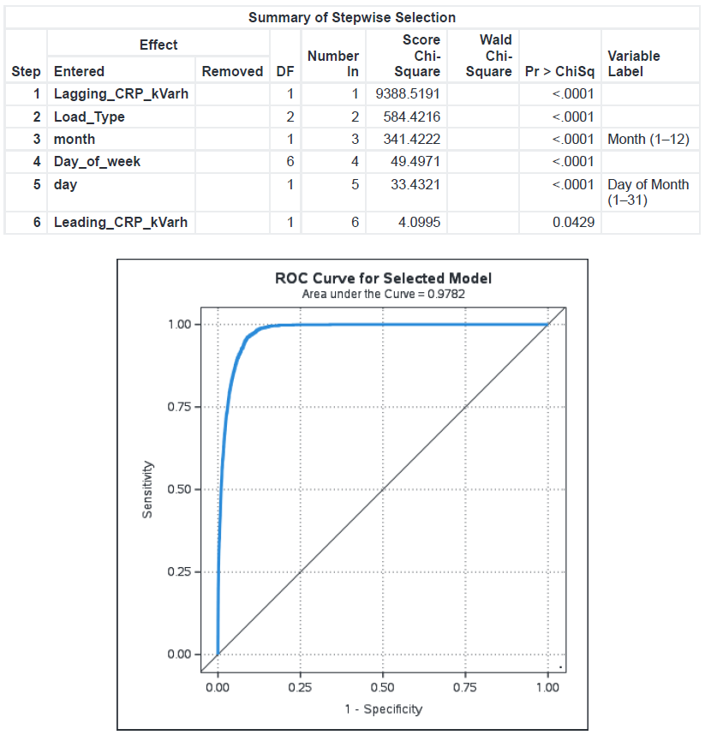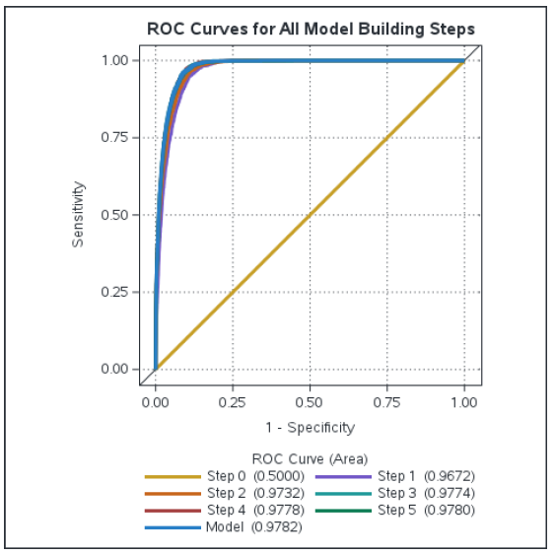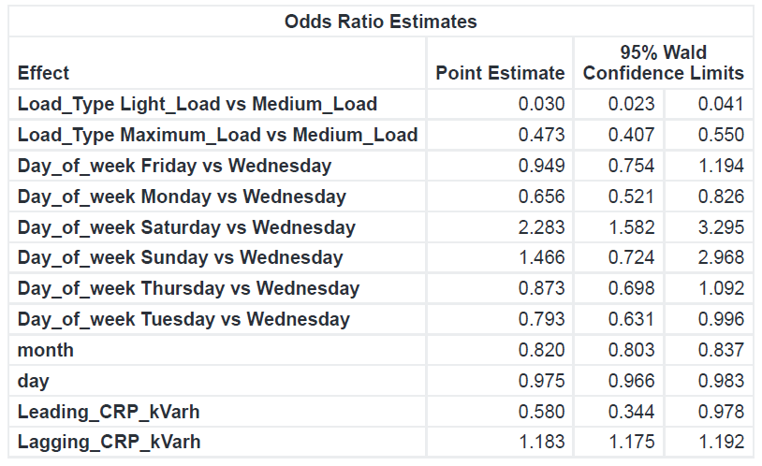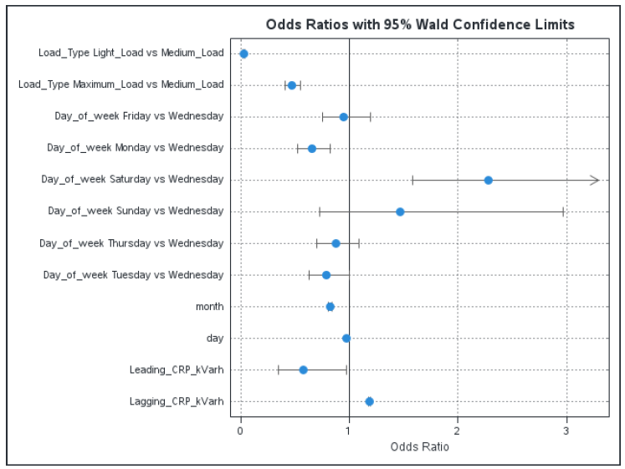
Figure 7. Stepwise Results of High Power Load Explanatory Model
Effects of Electrical and Operational Variables
Lagging_CRP_kVarh was the dominant predictor and entered first. In the final model, its coefficient was 0.1684, which corresponds to an odds ratio of 1.183 (95% CI 1.175–1.192). This means that each 1-unit increase in lagging reactive energy is associated with about an 18% increase in the odds of a high-load event, holding the other variables constant. Load_Type was also highly significant. Using Medium_Load as the reference, the odds of a high-load event for Light_Load intervals were only 3% of the odds for Medium_Load intervals (OR = 0.030, 95% CI 0.023–0.041), and the odds for Maximum_Load intervals were about 47% of those for Medium_Load (OR = 0.473, 95% CI 0.407–0.550). This reproduces the same pattern seen earlier in exploratory work: in this dataset, high-load events are most frequently associated with the medium operational state, while light-load intervals almost never trigger a high-load flag.
Time-related variables added clear structure. month had a negative coefficient (−0.1988; OR = 0.820, 95% CI 0.803–0.837), implying that each later month in the year reduces the odds of a high-load event by roughly 18%. Day_of_week captured a weekly pattern: relative to Wednesday, Saturday showed more than double the odds of a high-load event (OR = 2.283, 95% CI 1.582–3.295), while Monday (OR = 0.656, 95% CI 0.521–0.826) and Tuesday (OR = 0.793, 95% CI 0.631–0.996) showed significantly lower odds. day (day-of-month) had a small but significant negative effect (estimate −0.0254, OR = 0.975, 95% CI 0.966–0.983), indicating that high-load odds fall slightly across the month. Finally, Leading_CRP_kVarh entered last with a negative coefficient (−0.5449; OR = 0.580, 95% CI 0.344–0.978), meaning that higher leading reactive energy is associated with lower odds of a high-load event, even after accounting for lagging reactive energy and the calendar variables.
III. Interpretation and Limitations
This model shows that high power load events in the steel-plant dataset are highly structured rather than random. They occur most often when (i) lagging reactive demand is high, (ii) the plant is in its medium load state, and (iii) the interval falls on certain days (especially Saturday) and earlier months of the year. The fact that stepwise, forward, and backward selection all produced the same final set of predictors increases confidence that these are the core drivers in this dataset. At the same time, because the response is rare (1,682/35,040), we recommend complementing the very strong AUC (0.978) with precision–recall analysis or threshold-based evaluation if the model is to be used for real-time alerting on high-load intervals.

Power Factor Efficiency Explanatory Modelling

I. Methods
A binary logistic regression model was fitted to identify factors associated with power-factor efficiency at the 15-minute level. The dependent variable was defined as the absence of inefficiency, so the model estimated the probability that an interval was efficient (Is_Inefficient = “No”). Two categorical predictors were included: Load_Type (reference: Medium_Load) and Day_of_week (reference: Wednesday). Four continuous predictors were also considered: Usage_kWh, Leading_CRP_kVarh, month (1–12), and day (1–31). A stepwise selection procedure (score/Wald criteria) was used so that only variables providing statistically meaningful improvement in fit were retained. We also tested forward and backward selection and obtained the same final set of predictors, which supports the stability of the selected model. The analysis used all 35,040 available 15-minute observations from the prepared dataset, and the SAS task confirmed that the modeled event was Is_Inefficient = "No". During model building, additional categorical variables that were available in the dataset (Is_Holiday, Is_Workday, is_high_load, and WeekStatus) were explored but contributed negligibly once Day_of_week and the electrical variables were in the model, so they were not retained in the final specification.

II. Results

Model Building and Overall Fit
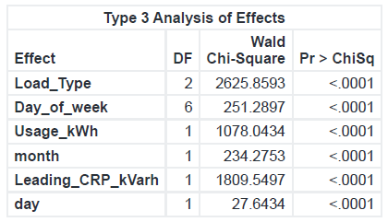
Figure 8. Type 3 Analysis - Power Factor Efficiency Explanatory Modelling
The stepwise procedure entered variables in the following order: (1) Leading_CRP_kVarh, (2) Load_Type, (3) Usage_kWh, (4) month, (5) Day_of_week, and (6) day. Each step reduced the −2 log likelihood and AIC, indicating that each newly added variable improved model fit. The final model showed a substantial improvement over the intercept-only model: the −2 Log L decreased from more than 48,000 to about 17,300. Discrimination was very strong, with a c-statistic of approximately 0.96, meaning that in about 96% of comparable pairs the model ranked an efficient interval ahead of an inefficient interval. This indicates that the chosen predictors are highly informative for the outcome.

Effects of Operational Categories
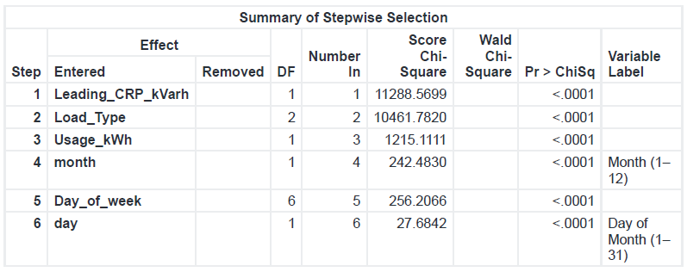
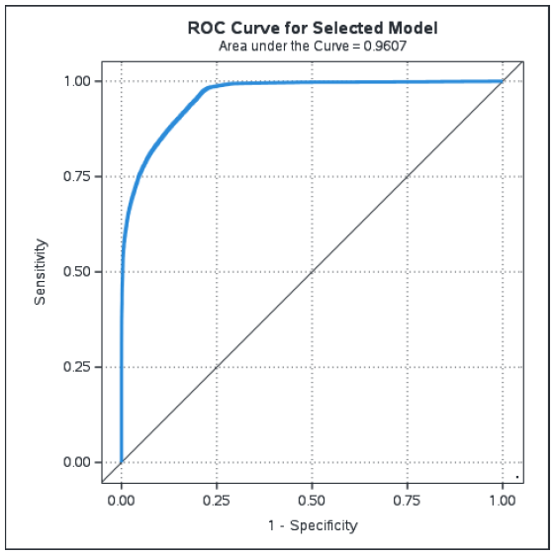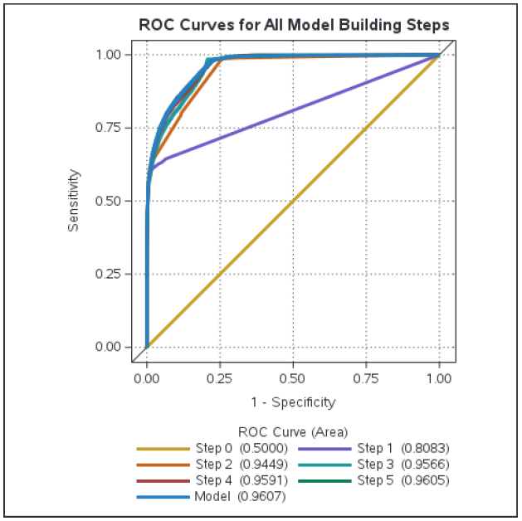

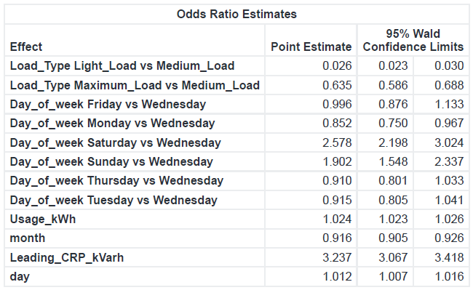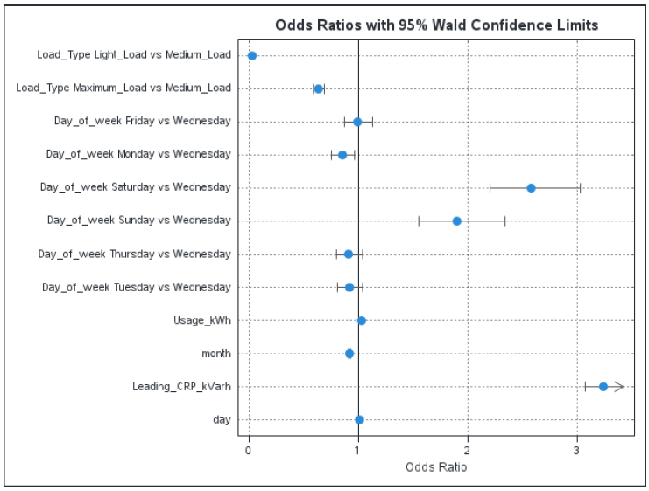
Figure 9. Stepwise Results of Power Factor Efficiency Explanatory Modelling
All retained effects were statistically significant in the final Type 3 tests. Load_Type was one of the strongest predictors. Relative to Medium_Load, intervals recorded as Light_Load had much lower odds of being efficient, and Maximum_Load intervals also had lower odds, although the reduction was not as extreme as for Light_Load. This pattern suggests that, in this dataset, the medium-load operating state is the condition most compatible with meeting the power-factor threshold, while lighter and peak-level operating states are more prone to failing it.
Day_of_week also contributed significantly. Compared with Wednesday, Monday showed a small but statistically significant reduction in the odds of efficiency. In contrast, Saturday and Sunday showed markedly higher odds of being efficient. This implies that weekend operation is, on average, electrically “cleaner” in terms of power factor than weekday operation, which may reflect a different mix of processes or lower concurrent demand on weekend days. Because Day_of_week already captures this calendar structure, broader calendar flags such as WeekStatus or Is_Workday did not add further explanatory power.

Effects of Electrical and Calendar Variables
Among the continuous variables, Leading_CRP_kVarh was entered first and remained strongly positive in the final model: higher leading reactive energy within an interval was associated with substantially higher odds that the interval would be classified as efficient. Usage_kWh also displayed a positive relationship with efficiency, indicating that, holding other predictors constant, intervals with higher active-energy usage were slightly more likely to meet the efficiency rule.
Two calendar variables were retained. month had an odds ratio below 1, indicating that the odds of an interval being efficient tended to decline as the year progressed. By contrast, day (day-of-month) had an odds ratio slightly above 1, suggesting a modest within-month tendency for efficiency to improve from one day to the next. These two effects together indicate that there is some slow calendar drift in efficiency across months, but also small day-to-day variation inside a given month.
III. Interpretation and Limitations
Overall, the model shows that power-factor efficiency in this steel dataset is not random. It is systematically related to: (i) the operating load type, (ii) the day on which the interval occurs, (iii) the reactive-power characteristics observed in that interval, and (iv) the position in the calendar. The most favourable conditions for meeting the power-factor requirement are medium-load operation, weekend days, intervals with higher leading reactive energy, and earlier months of the year. The fact that forward, backward, and stepwise procedures converged on the same set of predictors, and that broader calendar flags (Is_Holiday, Is_Workday, is_high_load, WeekStatus) were negligible once the main effects were in the model, strengthens confidence that this specification captures the core structure in the data. Because the model’s discrimination is very high (c ≈ 0.96), these predictors could be used in practice to monitor conditions under which inefficiency is more likely, or by reversing the event definition to flag intervals that are at higher risk of inefficiency.
Conclusion
This report successfully shifted the analytical focus from the predictive modelling of prior research to an explanatory framework, aiming to understand the underlying drivers of two critical operational states in a steel plant: high power load events (peaks) and low power factor (inefficiency). By applying binary logistic regression to a year of high-resolution data, this study achieved its objectives by developing two robust models with excellent discriminatory power (AUC 0.978 for high load; 0.961 for efficiency).
The key findings provide actionable insights that complement a predictive approach. The analysis of high-power load drivers revealed that peak demand events are not random; they are strongly associated with increases in lagging reactive power (Lagging_CRP_kVarh). Counter-intuitively, the Medium_Load operational state (not Maximum_Load), carries the highest association with peak events. This suggests a specific process unique to this state is responsible for high-demand spikes. Furthermore, peak events were found to be significantly more likely on Saturdays and earlier in the calendar year, providing clear time-based windows for intervention. Regarding power factor, the model for efficiency (Lagging CPF > 0.90) identified that the plant is most efficient during the Medium_Load state and on weekends. Conversely, inefficiency is most pronounced during Light_Load periods, a finding consistent with power systems theory. The strongest predictor of efficiency was Leading_CRP_kVarh, indicating that while existing capacitive correction measures are effective, they may be insufficient during these Light_Load periods.

Contributions and Actionable Insights
This explanatory analysis provides direct value to plant operators by answering "why" and "when" these costly events occur. While a predictive model might forecast that a peak is likely, this explanatory model suggests where to look. For peak management, rather than generic power saving measures, managers can now investigate the specific processes active during the Medium_Load state and on Saturdays to identify the root cause of demand spikes. Similarly, for efficiency management, the focus should be on the Light_Load operational state to avoid utility penalties.
Limitations and Future Work
The models, while statistically strong, rely on high-level categorical data (e.g., Load_Type). The "Future Work" originally identified in this report directly addresses this limitation. To move from identifying when (e.g., Medium_Load) to what (e.g., startup of a machine during production), future analysis would be greatly enhanced by incorporating more granular machine-level data, such as a detailed power usage breakdown by production floor and machine. This would allow models to pinpoint the specific assets responsible for peaks or poor power factor. Additionally, incorporating operational context like correlating energy data, with the number of workers on-site or specific production schedules could explain the "Saturday" effect and other temporal patterns observed in the models.
In conclusion, this explanatory approach has proven its value of converting raw IoT data into a clear narrative of plant operations and providing a foundation for targeted data-driven efficiency interventions
REFERENCES
Satishkumar, V. E., Shin, C., & Cho, Y. (2021). Eﬃcient energy consumption prediction model for a data analytic-enabled industry building in a smart city. Building Research & Information, 127-143. Retrieved from Building Research & Information: DOI: 10.1080/09613218.2020.1809983
Gajowniczek, K., & Zabkowski, T. (21 August, 2017). wo-Stage Electricity Demand Modeling Using Machine Learning Algorithms. Retrieved from Energies: https://doi.org/10.3390/en10101547
YT Electric. (10 July, 2024). Eletrcity penalty and poor power quality. Retrieved from YT Electric Blog: https://www.ytelect.com/blog/electricity-penalty-and-poor-power-quality_b205
EIA. (7 October, 2025). International Energy Outlook 2026. Retrieved from U.S. Energy Information Administration: https://www.eia.gov/outlooks/ieo/pdf/industrial.pdf
Schneider Electric. (n.d.). Learning about Power Factor. Retrieved from Meter Insights: https://meterinsights.schneider-electric.com/help/learning-about-power-factor
FLUKE. (n.d.). Power Quality. Retrieved from Power Factor: What it is and How to Calculate it: https://www.fluke.com/en-sg/learn/blog/power-quality/power-factor-formula
All About Circuits. (n.d.). Calculating Power Factor. Retrieved from Chapter 11: Power Factor: https://www.allaboutcircuits.com/textbook/alternating-current/chpt-11/calculating-power-factor/
Keysight. (n.d.). Power Factor Formula: Simplifying the Complex. Retrieved from Keysight: Official Used Equipment Store: https://www.keysight.com/used/us/en/knowledge/formulas/power-factor-formula
Singh, N. (4 August, 2025). Power Factor Improvement: Methods, Benefits & Techniques. Retrieved from Planet Spark: https://www.planetspark.in/communication-skills/power-factor-improvement
Elpro Electric. (2024). Understanding Power Factor and Its Impact. Retrieved from How Power Factor Correction Reduces Electricity Bill: https://elproelectric.ca/vancouver-electrician-guide-on-how-power-factor-correction-reduces-your-electricity-bill/
Optec. (2025). Q&A with Benno Unternahrer. Retrieved from Optec Expertise Solution: https://www.optec.ch/en/alt-expertise-solutions-/3-questions-3-answers/peak-load
Satishkumar, V. (2021). Steel Industry Energy Consumption [Dataset]. UCI Machine Learning Repository, https://doi.org/10.24432/C52G8C.
Holidays, O. (n.d.). National Holidays in South Korea in 2018. Retrieved from Office Holidays: https://www.officeholidays.com/countries/south-korea/2018

APPENDIX
Table 1: SAS Data and Meta Data
File Name | Description | Location/ Username in SAS
SummaryTable_original_dataset | Raw Data Summary | andre.ong.2024
Steel_Data | Original Dataset | andre.ong.2024
Steel_Data_3 | Final Dataset after Cleaning and Transformation | andre.ong.2024
Data Prep: Check for duplicated rows | Data Preparation Check: Checking for duplicated rows | andre.ong.2024
Data Prep: Check missing time | Data Preparation Check: Checking for missing datetime data | andre.ong.2024
EDA for Steel_dataset | Plot Correlation Matrix to identify highly correlated variables | andre.ong.2024
EDA_Mosaic Plot | Mosaic plots | andre.ong.2024
Additional columns for days (Steel_1) | Addition of month, day and time columns | andre.ong.2024
Additional columns for binning (Steel_2) | Addition of Is_Inefficient column and changing to binary values. | andre.ong.2024
Additional columns for binning (Steel_3) | Addition of is_inefficient and is_high_load variables | andre.ong.2024
Visual Detective_Bivariate Analysis | Histogram to check on separation of logistic regression variables | andre.ong.2024
Binary Logistic Regression_is_high_load_stepwise | Binary Logistic Regression 1 | andre.ong.2024
Binary Logistic Regression_is_inefficient _stepwise | Binary Logistic Regression 2 | andre.ong.2024
Table 2: Data Dictionary
Data Variable | Field Name | Data Type | Measurement
Industry Energy Consumption | Usage_kWh | Continuous | kWh
Lagging Current Reactive Power | Lagging_CRP_kVarh | Continuous | kVarh
Leading Current Reactive Power | Leading_CRP_kVarh | Continuous | kVarh
Carbon Dioxide Emissions | CO2_tCO2 | Continuous | Tonne
Lagging Current Power Factor | Lagging_CPF | Continuous | %
Leading Current Power Factor | Leading_CPF | Continuous | %
Number of Seconds to Midnight | NSM | Continuous | Seconds
Week Status | WeekStatus | Categorical | -
Day of the Week | Day_of_week | Categorical | -
Factory Activity Loading | Load_Type | Categorical | Light Load  Medium Load  Heavy Load
Date time | dt | Continuous | -
Date | d | Continuous | DD/MM/YYYY
Time | Time | Continuous | HH:MM:SS
Month | Month | Continuous | -
Day | Day | Continuous | -
Workday – if it’s a working day | Is_Workday | Categorical | Yes  No
Energy Efficiency -  Is Lagging Current Power Factor below 90%  (Target Variable) | Is_Inefficient | Categorical | Yes  No
High Power Load - Is Industry Energy Consumption Above 95th Percentile (100kWh)  (Target Variable) | Is_high_load | Categorical | Yes  No
Table 3: Load Type and Timings
Load type | June–August | March–May, September–October | November–February
Light load | 23:00 - 09:00 | 23:00 - 09:00 | 23:00 - 09:00
Medium load | 09:00 - 10:00 | 09:00 - 10:00 | 09:00 - 10:00
 | 12:00 - 01:00 | 12:00 - 01:00 | 12:00 - 07:00
 | 17:00 - 23:00 | 17:00 - 23:00 | 20:00 - 22:00
Maximum load | 10:00 - 12:00 | 10:00 - 12:00 | 10:00 - 12:00
 | 01:00 - 17:00 | 01:00 - 17:00 | 17:00 - 20:00
 |  |  | 22:00 - 23:00
From "Efficient energy consumption prediction model for a data analytic-enabled industry building in a smart city," by V. E. Sathishkumar, C. Shin, and Y. Cho, 2021, Building Research & Information, 49(1), p. 132.
Table 4: Korea Holidays 2018
Date | Day | Holiday Name
1-Jan-18 | Monday | New Year's Day
15-Feb-18 | Thursday | Korean New Year Holiday
16-Feb-18 | Friday | Korean New Year (Seollal)
17-Feb-18 | Saturday | Korean New Year Holiday
1-Mar-18 | Thursday | March 1st Movement Day
1-May-18 | Tuesday | Labor Day
7-May-18 | Monday | Children's Day Holiday
22-May-18 | Tuesday | Buddha's Birthday
6-Jun-18 | Wednesday | Memorial Day
13-Jun-18 | Wednesday | Local Election Day
15-Aug-18 | Wednesday | Liberation Day
23-Sept-18 | Sunday | Harvest Festival Holiday
24-Sept-18 | Monday | Harvest Festival (Chuseok)
25-Sept-18 | Tuesday | Harvest Festival Holiday
3-Oct-18 | Wednesday | National Foundation Day
9-Oct-18 | Tuesday | Hangeul Day
25-Dec-18 | Tuesday | Christmas Day
Adapted from "National Holidays in South Korea in 2018," by Office Holidays, n.d. (https://www.officeholidays.com/countries/south-korea/2018).
SAS and all other SAS Institute Inc. product or service names are registered trademarks or trademarks of SAS Institute Inc. in the USA and other countries. ® indicates USA registration.
Other brand and product names are trademarks of their respective companies.

